الاسم : عمر محمد محمود حسنين (2)

Chapter 10
Choices:
1) Which method is called when entering a context manager block using with (b)
2) Which keyword is used in Python generators (b)
3) In the Observer pattern, what is the primary responsibility of the Subject? (b)
4) Which design pattern ensures only one instance of a class exists? (b)
5) Which of the following is NOT a benefit of Dependency Injection? (c)
True or false:
1) The __exit__() method in a context manager is always executed, even if an exception occurs inside the with block (true)
2) Generators return all values at once like a list (false)
3. Coroutines can both produce values and receive input using send() (true)
4. The Factory pattern is used to notify multiple observers when the state of an object changes.(false)
5. Dependency Injection helps reduce coupling between classes (true)
Short answers:
- What is the difference between a generator and a coroutine in Python?
Answer: A generator produces values lazily using yield, while a coroutine can also consume values sent into it using send(). Coroutines are often used for event-driven programming and concurrency .
- Explain why the with statement is preferred over manual resource management.
Answer: The with statement ensures resources (like files, sockets, or locks) are automatically cleaned up via __exit__(), even if an exception occurs, making code safer and cleaner .
- Give a real-world example where the Observer pattern might be applied.
Answer: In a stock trading app, multiple UI components (observers) need to be updated whenever stock prices (subject state) change .
4. What problem does the Factory pattern solve? Answer: It abstracts object creation, allowing clients to create objects without depending on their concrete classes .
5. How does Dependency Injection improve testability of code?
Answer: It allows dependencies (like services or databases) to be swapped out with mock objects during testing, making unit tests easier and more isolated .
Problems:
Problem 1: 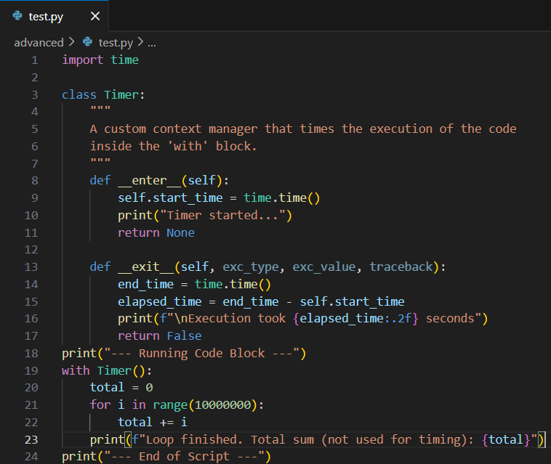

Problem 2: 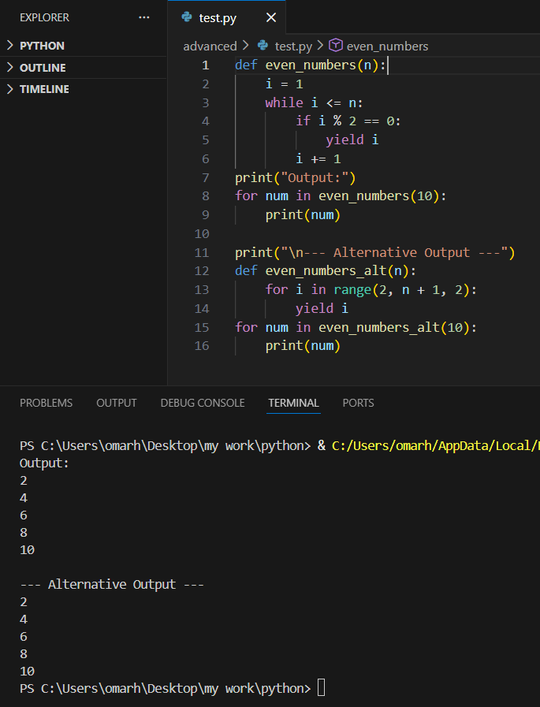
Problem 3: 